Wang's Martial Arts
92-B Wilson Rd.
Humble, TX 77338
U.S.A.
Phone (281) 548-1638, (281) 682-3387
School Phone number:
281-548-1638,
281-682-3387 ( Cell )
E-mail: wang3888@embarqmail.com
Web site: www.WangsMartialArts.com
April 2012 Newsletter Summary
Proverbs 4 .
¹⁸ The path of the righteous is like the morning sun,
shining ever brighter till the full light of day.
¹⁹ But the way of the wicked is like deep darkness;
they do not know what makes them stumble.

INNER SCHOOL TOURNAMENT
Date: 06-30-2012 (Saturday)
Time: Ages 5 - 80 2:00 PM – 5:00 PM
Entry Fee: $40.00 up to three events
$ 5.00 goes to scholarship fund

Brown and Black rank test
April 17, 2012 (Tue.) 6 – 8 pm
April 19, 2012 (Thur.) 6 – 8 pm
April 21, 2012 (Sat.) 9 am – 3 pm

Wang's Martial Arts Outdoor practice on 03-25-2012

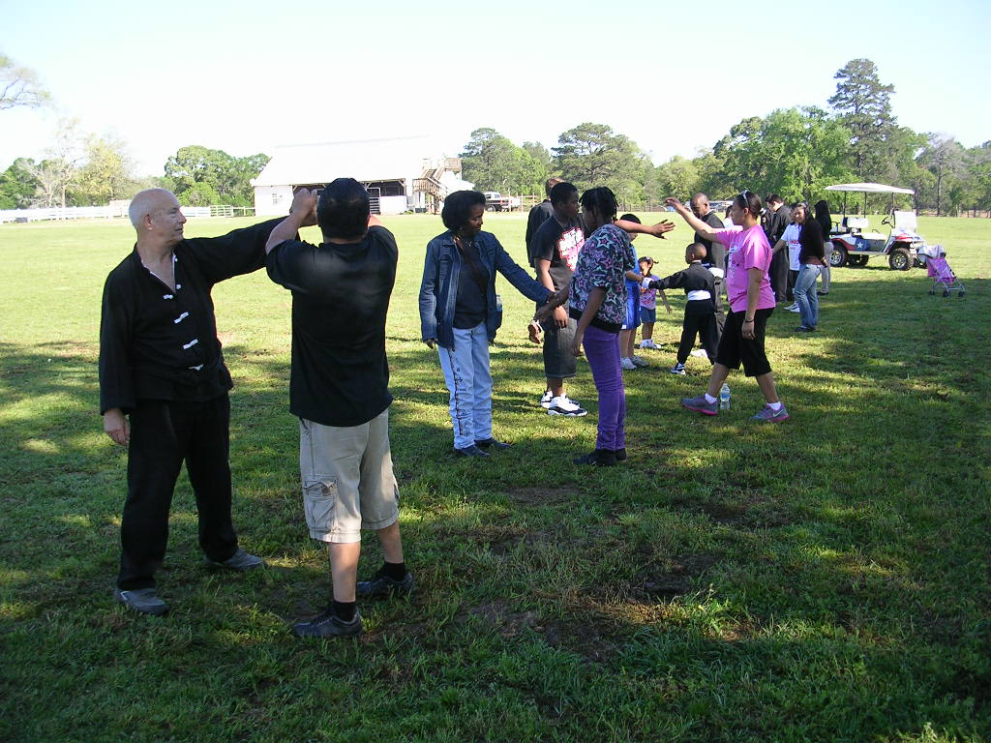 | 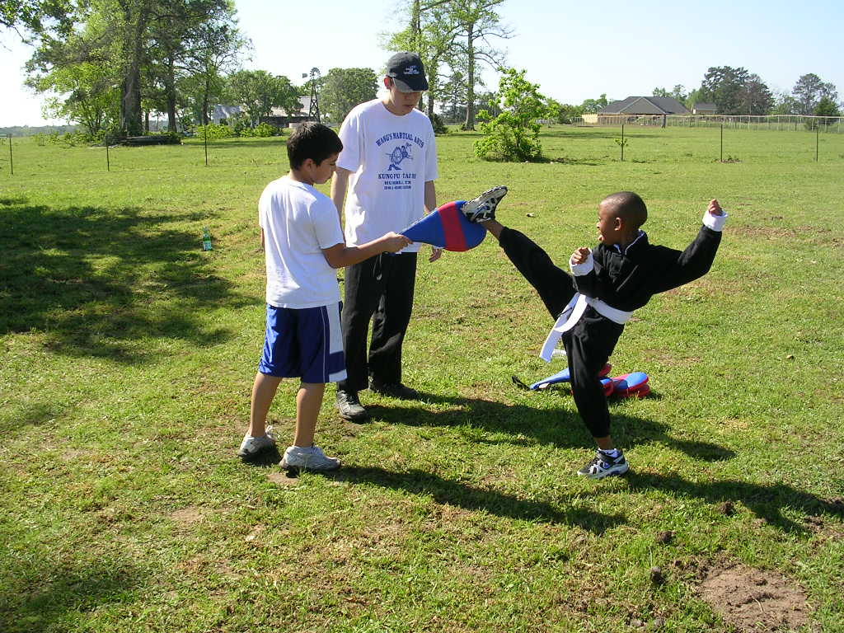
Outdoor training. | High kick.
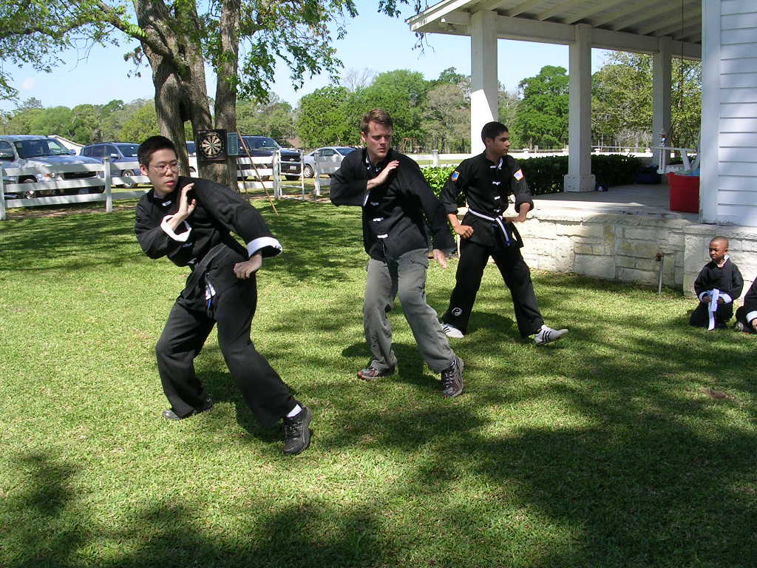 | 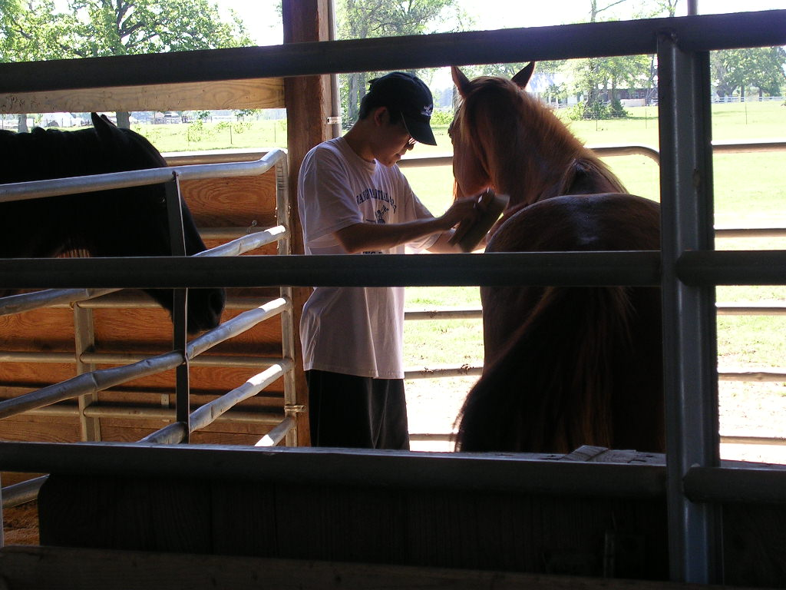
Demo by Wilfred, Daniel and Jose. | Wilfred and horse.

Wang's Martial Arts students, families & friends had a great day in the country ranch with fun morning training in fresh air & sunshine. Afternoon was demonstration time. Games of skill, throwing darts, blow darts, egg toss contest, water balloon to cool off which gave everyone a chance to join in the fun. The pony rides and golf carts were crowd favorites. Lunch was potluck style & barbeque.

Black Belt Club & Accelerated Program

Tournament Competition Class:
Date: 4-7-12 (Saturday)
Time: 1:00 – 2:00 pm
Nunchaku Class:
Date: June 4, 2012 (Monday)
Time: 7:00 – 9:00 pm

Conditioning & Reaction Drill Class:
Age 5 –12 years old
Date: 4/19/2012 (Thursday)
Time: 8:00 – 9:00 pm
Age 13 – 80 years old
Date: 4/12/2012 (Thursday)
4/26/2012 (Thursday)
Time: 8:00 – 9:00 pm

Basic Bo
Dates: 5-05-2012 (Sat.) Time: 2-3 pm
5-12-2012 (Sat.) 2-3 pm
5-19-2012 (Sat.) 2-3 pm
Cost: $39.00 or $19.50 for review
Pre-requisite: Adults (15 years old and up) –Yellow belt and up.
Jr. students (5–14 years old)- green belt and above. (Minimum 6 people register.)
Wang’s Martial Arts College Student Scholarship Fund:
2009 Scholarship Fundraising Banquet - $628.98
Inner-School tournament:
December 5, 2009 - $105.00
March 6, 2010 - $85.00
July 10, 2010 - $100.00
December 6, 2010 - $105.00
March 19, 2011 - $80.00
June 4, 2011 -$115.00
September 10, 2011 - $150.00
December 3, 2011 - $110.00
March 3, 2012 - $150.00
Outdoor Training (3-25-12) -$100.00
Total - $1728.98
Current student at Wang’s Martial Arts who is taking 12 or more credit hours at semester final report card:
All A’s - $300.00
A & B’s - $200.00
All B’s - $100.00

April Birthdays

Jeremy Moore 4/06
Terri Scott-Dennis 4/22
Andre Brower 4/23
Joseph Barela 4/20
Chris Avelar 4/15
Diego Ramirez 4/10
Joseph Barela 4/20
Justin Steelman 4/03
Andrew Medrano 4/04
Donovan Landry 4/28
Lisa Whitehead 4/16
Martin Wheeler 4/22
Happy Birthday

New Student:
Davion Roque, David Rodriquez,
Robert Kerr, Julie Kerr,
Enrique Goytizolo, Gala Fuentes,
Andrew Medrano, Ryan Russell,
Gage Garcia, Donavan Landry,
Lauryn Landry, Salim Smith,
Oscar Gomez, Marsnall Little
Welcome!

Tai Chi Test Result: 3/24/2012
Paul Greenwood - Yellow Belt
Philip Spruell - Yellow
Adela Leso -Green
Deborah Green - Green
Valerie Roll - Purple
Mary Ann Bush - Purple
Norma Rosenberger - Red
Polly Ferguson - Red
Sandra Dunsmore - Red
Susan Fishman - Red
Steve Alonso - Brown
Paul Turk - Brown
Russell Haws - Black (4th)
Congratulations!

Chinese Vegetarian Food & Tour Chinatown

Date: 06-09-2012 ( Saturday )
Time: 1:00 pm Meet at Wang’s Martial Art.
Place: 2:30 pm Pine Forest Garden Vegetarian Restaurant
9108 Bellaire Blvd. At Ranchester.
Houston, TX 77036
(713) 772-2888, (281) 682-3387 (Cell )
Cost for Food: $10.00 for 10 years old and above.
(Includin food, tax, tip, soft drink or tea. )
$ 8.00 for 9 years old and younger.
Nunchaku Class:

Date: June 4, 2012 (Monday)
Time: 7:00 – 9:00 pm
Cost: $19.00
Free for Black Belt Club members.
Tournament Point:

Emmory leach 30
Marvin Henderson 30
Jaqueline Ajucum 30
Jose Guzman 24
Diego Ramirez 21
Darren Bush 21
Andrik Sanchez 18
Chris Avelar 18
Brandon Roll-Bush 15
Conner Roll-Bush 15
Brandon Sarton 15
James Dyess 6
Rosalie Conry 6

Be sure turn in your tournament point. For point 2012, every one must turn in before 12-31-2012.
Report card point:
Aramis Valdivia - 5.25
Mireya Mendoza - 4.50
Brandon Roll-Bush - 4.50
Conner Roll-Bush - 4.50
Kayla Warner - 3.00
Sean paul - 3.00
Brandon Warner - 2.25
Sebastian Garcia - 2.25
Mireya Mendoza - 2.25
Kevin Papa - 2.25
Emmory leach - 2.25
Dirgo ramirez - 1.50
Julian Rosas - 0.75
Alex Solhjou - 0.75
Sara Solhjou - 0.75
James Bolton - 0.75
Nick Limones - 0.50
Dustin Ferguson - 0.50

Be sure turn in a copy of your report card as you receive it. For point 2012, every one must turn in before 12-31-2012.

Tai Chi Rank Test
Date: 6-23-2012 ( Sat. )
Time: 12 noon – 2:00 pm

Tournament Points: Don’t forget to turn in your points after each tournament for a chance to win a seven foot trophy at the Chinese New Year Banquet!
1st Place-12pts; 2nd Place-9pts; 3rd Place-6pts; Participation-3pts

Accelerated program Rank Test
Date: 4-28-2012 ( Sat. )
Time: 2:00 pm –4:30 pm

Report Card Points – Turn in your report cards all year long for a chance to win a seven foot trophy at the Chinese New Year Banquet!
All A’s-12pts; A’s & B’s- 9pts; All B’s-6pts; Turn in your report card – 3pts

Red, Brown and Black Belt Class
Every Saturday morning from 9:00 – 10:00 am

Kung Fu Rank Test
Date: 9-14 yrs: 3-29-2012, Thursday, 6-8:30 pm
5-8 yrs: 3-31-2012, Saturday, 1:30-3:30 pm
15 yrs +: 3-31-2012, Saturday, 3:30-5:30 pm
Must register on or before 3-24-2012.
Test fee : $35.00 and up
Bill "Superfoot" Wallace seminar
Date: April 20, 2012 (Friday)
Time: Age 5 - 14 years old Age 15 - 80 years old
6 - 7:15 pm 7:30 - 9:00 pm
Cost: $34 $44

2012

Tenth Annual Chinese New Year Banquet

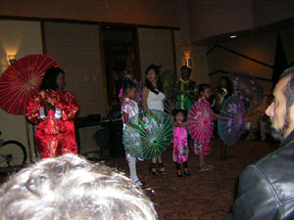 | 
Chinese Fashion Show. | Wang's Martial Arts Black belt.
 | 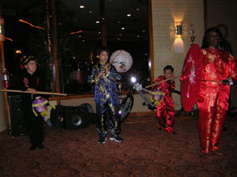
Daniel Hernandez. | Chinese Fashion show.
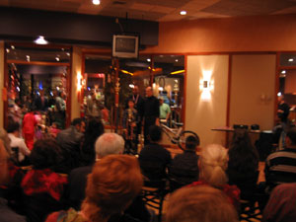 | 
Chinese New Year program | Jaquline Ajucum.

Wang's Martial Arts
92 – B Wilson RD.
Humble, TX. 77338
Harris County
Phone (281) 548-1638, (281) 682-3387 (cell)
Email: wang3888@embarqmail.com

Chinese Vegetarian Food & Tour Chinatown

Date: 06-09-2012 (Saturday)

Time: 1:00 pm - Meet at Wang’s Martial Art.


Place: 2:30 pm -
Pine Forest Garden Vegetarian Restaurant
9108 Bellaire Blvd. At Ranchester.
Houston, TX 77036
(713) 772-2888
(281) 682-3387 (Cell phone for Instructor Wang)

Cost for Food: $11.00 for 10 years old and above.
(Including food, tax, tip, soft drink or tea.)
$ 8.00 for 9 years old and younger.

---------------------------------------------------------------------------------------------------------------------

Registration Form

Name : ________________________________________ . Date : ____________________

Address : __________________________________________________________________

Home Phone : __________________________ . Work Phone : _______________________

Cell Phone : ____________________ e-mail:_____________________________________________

Number of People ( 10 years and above): _________ x $11.00 = ________________

( 9 years and younger) ________ x $ 8.00 = ________________

( Total Amount Paid ) = ________________

Wang's Martial Arts
92-B Wilson Rd.
Humble, TX. 77338
U.S.A.
Phone (281) 548-1638, (281) 682-3387
e-mail: wang3888@embarqmail.com
Web site: http:// www.WangsMartialArts.com

Membership Drive : 2012

Current students bring some one to sign up at Wang’s Martial Arts
One week special - $19.00 with Free School T-shirt (value $10.00)
Before May 31, 2012.
When your guest sign up, you will receive choice of $5 Starbucks card or Best Buy card.
Student who has most of the members signed up before 5-31-12.

1st Prize: Sony Playstation 3

2nd Prize: Bicycle

3rd Prize: Kicking shield.

4th Prize: Kicking Target


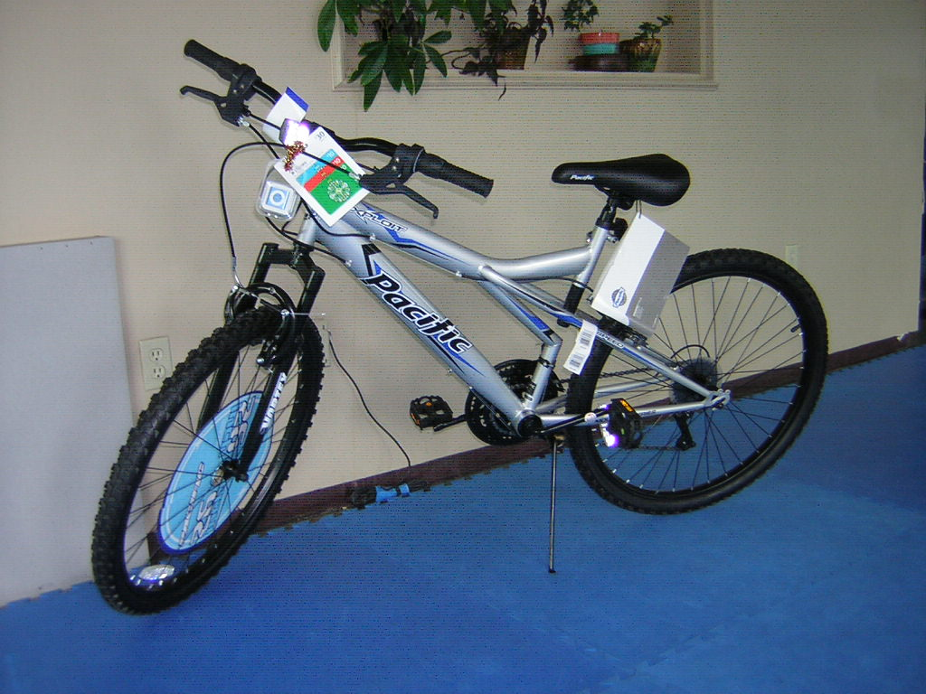
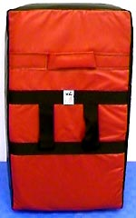

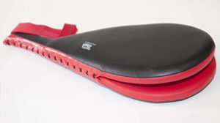

Date of Award: June 02, 2012
Saturday
Time: 10:00 - 11:00 am


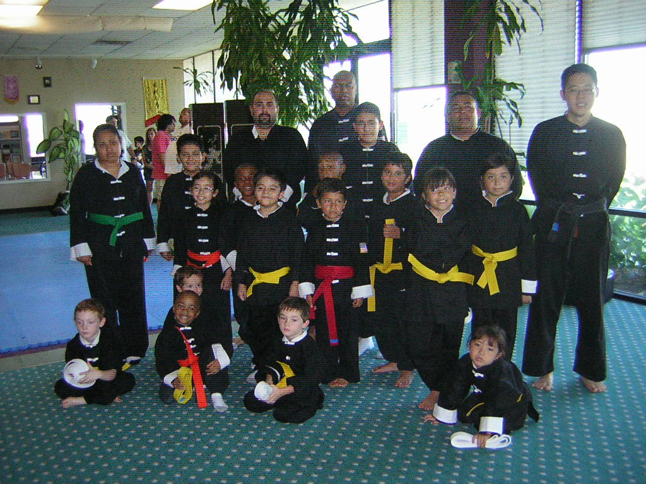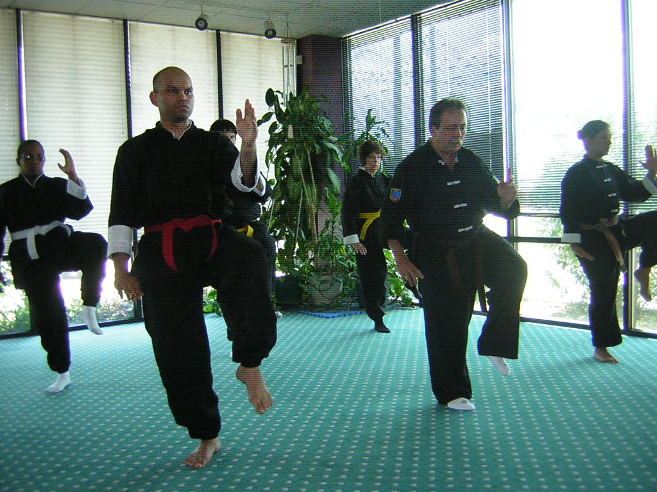

Kung Fu Or Tai Chi
One Week Special- $19.00 with unlimited class
Free School T-shirt (value $10.00)
(Good till 5-31-2012.)

Wang’s Martial Arts
92– B Wilson Road
Humble, TX 77338
(281) 682-3387, (281) 548-1638
www.WangsMartialArts.com
KUNG-FU
Adults (Age 15-80) Tue. Sat. 11:00 - 12:00 Noon
Mon./Tue./Thur./Fri. 7:00 - 8:00 PM
Wed. 8:00 - 9:00 PM
Tues./Thur. 4:00 - 5:00 PM
Children (Age 5 - 14) Tue./Thur. 5:00 - 6:00 PM
Mon./Tue./Wed./Thur./Fri. 6:00 - 7:00 PM
Saturday 10:00 - 11:00 AM
Family class (Age 5-80) Tue./Thur. 5:00 - 6:00 PM
Mon./Wed./Fri. 6:00 - 7:00 PM
Saturday 10:00 - 11:00 AM

T’AI CHI CHUAN
All ages Tue. Sat. 12:00 Noon- 1:00 PM
Mon./Wed./Fri. 5:00 - 6:00 PM
Wed. 7:00 - 8:00 PM
Tue. 8:00 - 9:00 PM

Name: ______________________ is guest of ________________________ .

(Students! When your guest sign up, you will receive choice of $5 Starbucks card or Best Buy card.)

_______________________________________ Date: ____________________________________
Yun Yang Wang, Chief instructor

Wang's Martial Arts
92 – B Wilson Rd.
Humble, TX. 77338
U.S.A.
Phone (281) 548-1638
(281) 682-3387
e-mail wang3888@embarqmail.com
Web site www.WangsMartialArts.com

Nunchaku Class
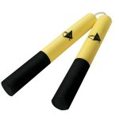

Date: June 04, 2012 (Monday)

Time : 7:00 - 9:00 PM

Place : Wang’s Martial Arts
92 – B Wilson Road
Humble TX, 77338
(281) 548-1638
(281) 682-3387

Fee : $19.00, Free for Brown, Black, Jr. Black
& Accelerated program.

Need bring your own nunchaku or purchase a foam nunchaku for $8.00 to $15.00 -----------------------------------------------------------------------------------------

REGISTRATION FORM

NAME:________________________________________ DATE:___________________

STREET:________________________________________________________________

CITY:_____________________________ STATE:____________ ZIP:______________

PHONE (HOME):__________________ PHONE (WORK):_______________________

Amount Paid ___________________________ .

Wang's Martial Arts
92-B Wilson Road
Humble, TX 77338
U.S.A.
Phone (281) 548-1638, (281) 682-3387
e-mail: wang3888@embarqmail.com
Web site: www.WangsMartialArts.com
INNER SCHOOL TOURNAMENT

Date: 06-30-2012 (Saturday)

Time: Ages 5 - 80 2:00 PM – 5:00 PM

Place: Wang’s Martial Arts
92 – B Wilson Road at First St.
Humble, TX 77338
(281) 548 - 1638
Entry Fee: $40.00 up to three events
$ 5.00 goes to scholarship fund

Listed below are the divisions; in each, a first, second, and third place trophies will be awarded.
Encouragement awards are given for everyone who does not place.
***** FORMS***** *****WEAPONS*****
Ages 5-8 Beg./ Int./ Adv. Ages 5-14 Beg./ Int./ Adv.
Ages 9-14 Beg./ Int./ Adv. Ages 15-17 Beg./ Int./ Adv.
Ages 15-17 Beg./ Int./ Adv. Ages 18-80 Beg./ Int./ Adv.
Ages 18-80 Beg./ Int./ Brown/ Black.
TAI CHI Beg./ Int./ Adv.

*****SPARRING*****
Ages 5-8 Beg./ Int./ Adv. (Boys & Girls)
Ages 9-14 Beg./ Int./ Adv. (Boys)
Ages 9-14 Beg./ Int./ Adv. (Girls)
Ages 15-17 Beg./ Int./ Adv. (Boys)
Ages 15-17 Beg./ Int./ Adv. (Girls)
Adult Men Beg./ Int./ Brown & Black.
Adult Women Beg./ Int./ Brown & Black

Registration form for INNER-SCHOOL TOURNAMENT

NAME: ________________________________________________________ DATE: ____________________

ADDRESS: _________________________________________________________________________________

CITY: _________________________________________, STATE: ___________ ZIP: ____________________

HOME PHONE: ______________________________WORK PHONE: _________________________________

CELL PHONE: __________________________e-mail address: _________________________________________

RANK: _____________________ AGE: _________________ DATE OF BIRTH: __________________

DVISIONS: FORMS _____ SPARRING _____ WEAPONS _____ Amount Paid______________

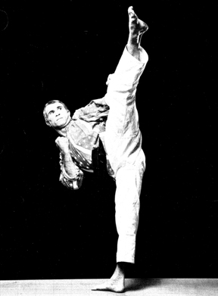

BILL "SUPER FOOT" WALLACE SEMINAR

Date: April 20, 2012 ( Friday)

Time & Fee:
Age 5-14 years old 6:00-7:15 pm
(Pictures & autograph 7:15 - 7:30 pm)
$34.00 (maximum 30 people)
Age 15-80 years old 7:30 - 9:00 pm
(Pictures & autograph 9:00 - 9:15 pm)
$44.00 (maximum 30 people)

PLACE: WANG'S MARTIAL ARTS
92-B Wilson Rd. at First Street
Humble, Texas 77338
281-548-1638, 281-682-3387

Bill "Superfoot" Wallace -American Karate Champion, instructor, author, actor, and referee. World professional middleweight champion since 1974 for the PKA, Wallace won many point tournament competitions prior to entering the professional ring, including the U.S. Championships and USKA Grand Nationals three times each, and the top 10 Nationals twice. He was rated top fighter in the country three times by Black Belt magazine. A superstar of full contact fighting, he is also a noted official and served as chief referee at the 1975 U.S. Championships.
Wallace started in Judo. He took up Karate in 1966 while serving in the U.S. Air Force. His first instructor was Michael Gneck, a Shorin-Ryu stylist who taught Wallace in San Bernadino, California. Wallace trained religiously seven days a week on a four-to-midnight schedule and won his black belt in one year. He returned to his home state of Indiana in 1968 where he began working out with Glenn Keeney in Anderson. While he never adopted any of Keeney's Shorei-Goju style, Wallace credits much of his sparring ability to those early workouts. While studying physical education at Ball State University, he entered and won his first tournament as a black belt at the Mid-East Nationals in Lexington, Kentucky in January 1968. After losing his next three consecutive tournaments, he launched a spectacular winning streak that continued to September 1974 when he turned to full contact karate. Wallace received his Bachelors degree in 1972 and completed his Master's at Memphis State University, where he then taught a physical education program which included Karate and Judo.
Wallace conducted seminars in Europe, South America, England, and throughout the U.S. He once taught at the Elvis Presley-owned studio, the Tennessee Karate Institute where Presley trained with Wallace briefly. He co-authored a college text, Karate's Basic Skills and Concepts. Voted into the Black Belt Hall of Fame as "Man of the Year" for 1978, he was twice elected "Karate Player of the Year." Wallace co-starred in the Chuck Norris film, A Force of One. He is Member of Who's Who in the Martial Arts.
A Tae Kwon Do/Shorin-Ryu stylist, he is noted for his fast left roundhouse kick and left hook kick. In the pro ring he is remembered for his quick left leg, which gave him the name "Superfoot." Wallace's ring history is 21-0, 11 KO's. He is the only full contact world champion to retire undefeated.

Registration Form for Bill "Superfoot" Wallace Seminar at Wang's Martial Arts, April 20, 2012.

Name: ____________________________________________________ Date: _________________________________

Address:____________________________________________________________________________________________

_____________________________________________________________________________________________

Home phone: ______________________, Work phone: _________________________, Cell phone: ___________________

e-mail: __________________________________________________________________ AMOUNT PAID: ________
Tournament results - 03/03/2012

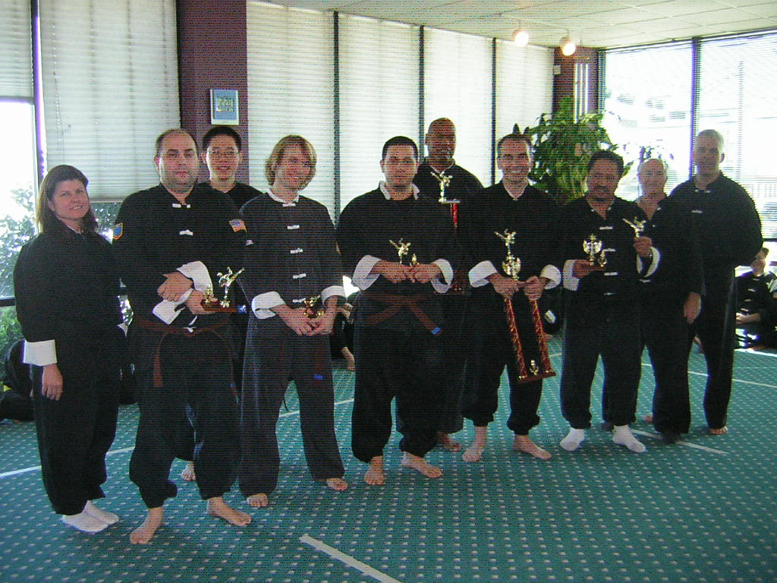 | 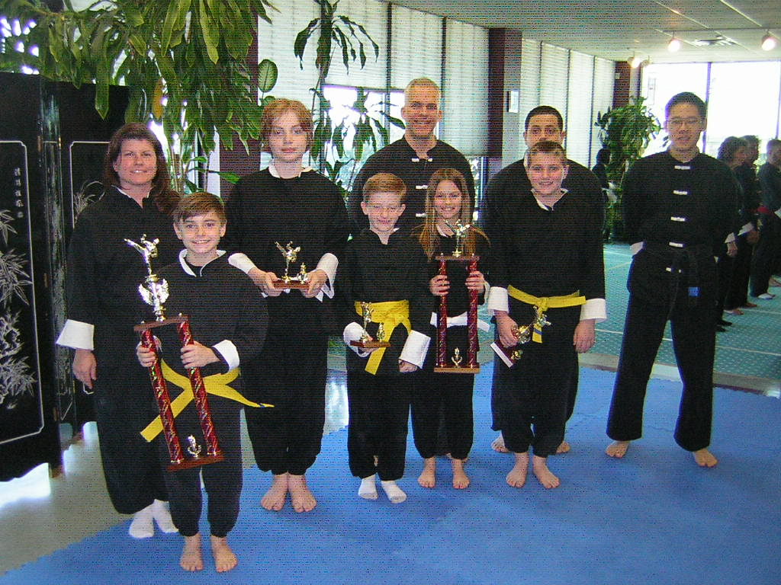
 | 

Forms:
Adult Brown & Black: 1. Allen, 2. Marvin Henderson, 3. Chris Castillo
Adult Int. : 1. Elmer Whitehead, 2. Darren Bush, 3. David Wilkerson
Adult Beg. : 1. Julie Rogers, 2. Susan Fischman, 3. Rosie Conry
Tai Chi: 1. Paul Turk, 2. Rick Strickland, 3. Marilyn Kidd
12-15 Adv. : 1.Jose Guzman, 2. Josh Moricca
9-14 Adv.: 1. Emmory Leach, 2. Diego Ramirez, 3. Brandon Roll-Bush
9-14 Beg.: 1. Andrew Bolton, 2. Kayla Warner, 3. Brandon Warner.
5-8 Int. : 1. Andrik Sanchez, 2. Jaquline Ajucum, 3. Conner Roll-Bush

Weapons:
Adult Brown & Black: 1. Allen, 2. Marvin Henderson, 3. Chris Avelar
Adult Int. : 1. Elmer Whitehead, 2. Darren Bush, 3. David Wilkerson
12-15 Adv. : 1.Jose Guzman, 2. Josh Moricca
5- 14 Int. : 1. Jaquelin Ajucum, 2. Emmory Leach, 3. Diego Ramirez
Tai Chi: 1. Susan Fischman, 2. Paul Turk, 2. Rick Strickland, 3. Steve Alonso, 3. Marilyn Kidd

Sparring:
Adult Brown & Black: 1. Marvin Henderson, 2. Chris Avelar, 3. Allen, 3. Josh Moricca
9-14 Int.: 1. Emmory leach, 2. Jaquline Ajucum, 3. Diego Ramirez, 3. Andrik Sanchez
9-14 Beg.: 1. Seth Rogers, 2. Brandon Roll-Bush 3. Brandon Warner, 3. Kayla Warner
5-8 Beg. : 1. Brandon Sarton, 2. Conner Roll-Bush

Rank test results on March 31, 2012 for age 15 - 80  Julius Herron - Yellow  Rosie Conry - Yellow  Charles Cates - Yellow/stripe  Michelle Henderson - Yellow/stripe  Susan Fischman - Orange  Julie Rogers - Orange  Amy Gilman - Orange/stripe  Elizabeth Lehmann - Purple  Adela Leso - Purple/stripe  Nigel Singh - Blue  David Wilkerson - Blue  Carrie Wilkerson - Blue/stripe  Marvin Henderson - Red/stripe | Age 9 - 14 years old  Gregory Strickland - Yellow  LaSha Lewis - Yellow  Luis Limones - Yellow  Seth Rogers - Yellow  Kayla Warner - Yellow  Kameron Guevara - Yellow  Brandon Sarton - Yellow  Cydni Hernerson - Yellow/stripe  Andrew Bolton - Orange  Brandon Warner - Orange  Valerie Campa - Orange/stripe  Liliana Campa - Orange/stripe  Brandon Roll-Bush - Green/stripe
Age 5-8 years old  Traviona Jones - Yellow  Julius Herron, II - Yellow  Gala Fuentes - Yellow  Austin Abner - Yellow  Nick Limones - Yellow/stripe  Nazir Barahona - Orange/stripe  Melanie Campa - Orange/stripe  Conner Roo-Bush - Green/stripe  Kevin Papa - Green/stripe  Carlos Gamboa - Green/stripe  Mark Limones - Purple  Ayden Sowers - Blue/stripe  Andrik Sanchez - Blue/stripe  Kaeden Sims - Red | 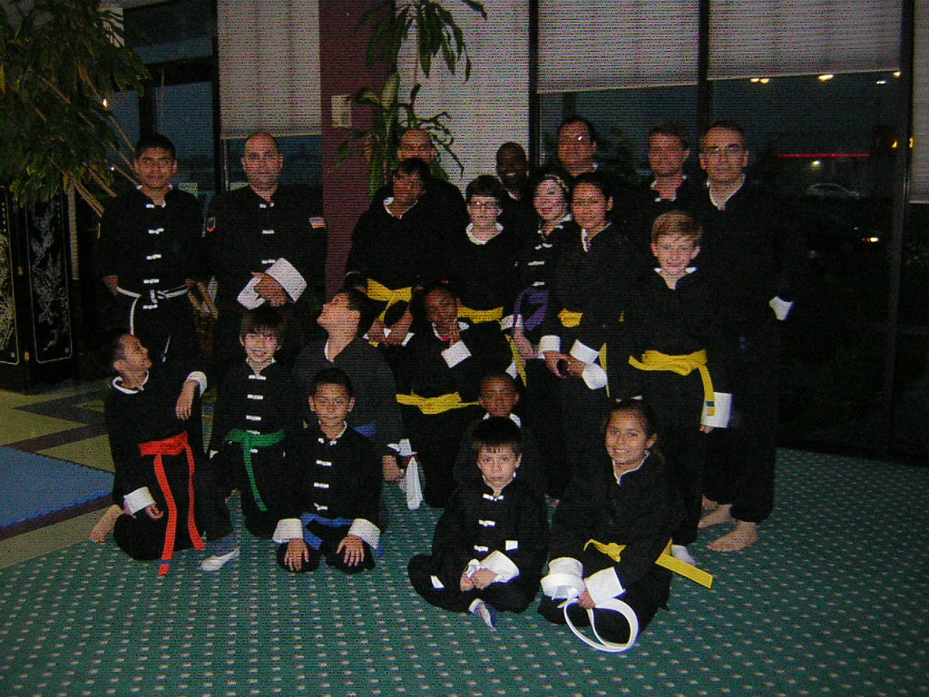
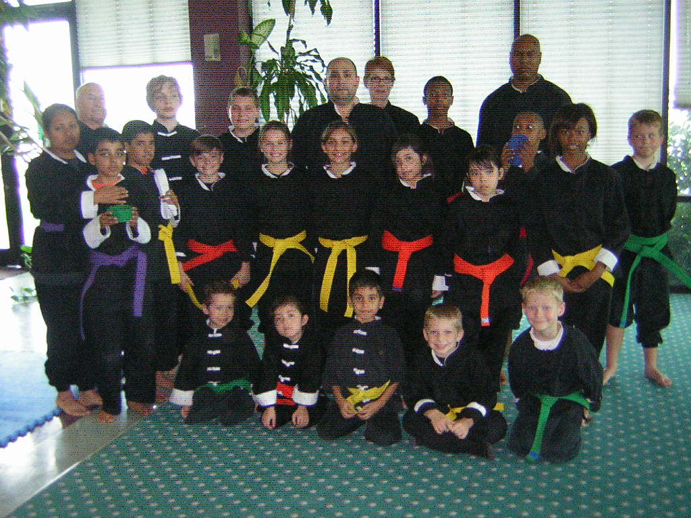 | 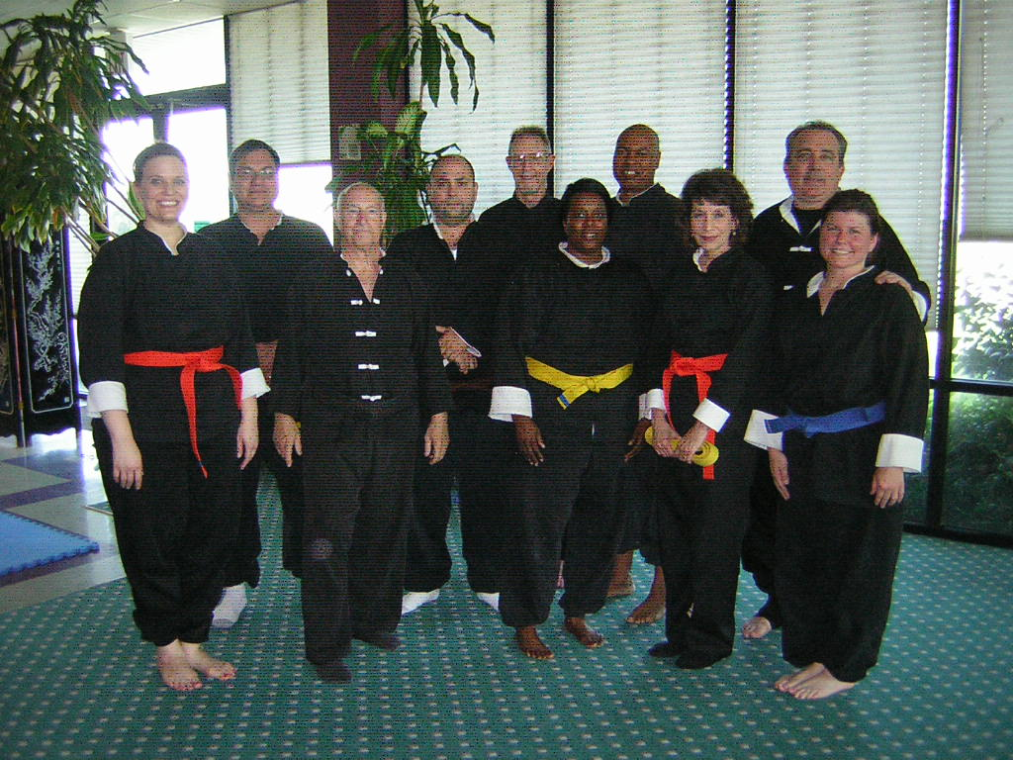
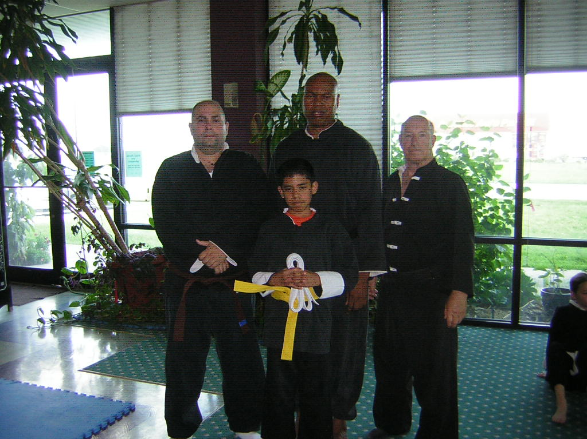 | 